Mapping Westchester County Application

User Guide

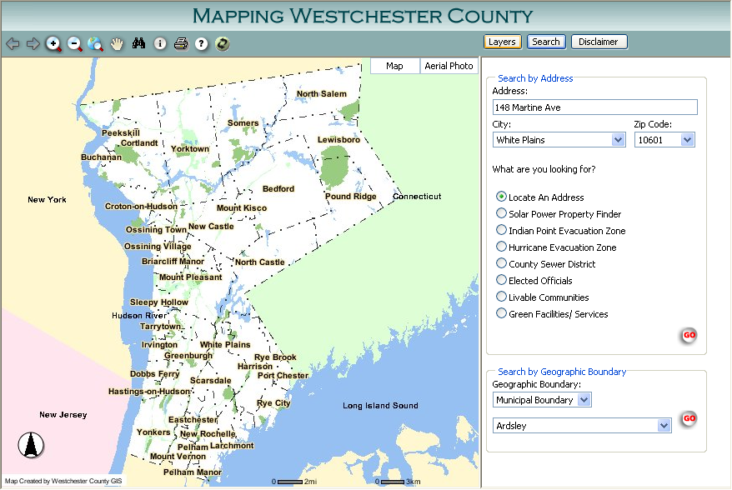

This Livable Communities initiative is brought to you in collaboration with the Westchester County Department of Information Technology. As always, we continue to strive to provide our Livable Communities and residents with options to support mobility, independence and improved quality of life.
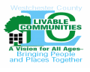

Westchester County’s Livable Communities: A Vision for All Ages-Bringing People and Places Together began in June, 2006, when it was launched before an audience of 250 community stakeholders. These stakeholders are providers, consumers, representatives from business, corporations, government agencies and community and faith-based organizations. The LC project has become a model that communities across the nation are following. It is a “citizens’ engagement and empowerment program” that is strengthening Westchester’s communities through a network of public and private entities and volunteer services.

The ongoing purpose of the Livable Communities project is to identify and develop ways for more seniors to “age in place.” That means they would be able to continue to live in their homes as they grow older with dignity, independence and civic involvement rather than be forced to relocate prematurely - if at all. Study after study has shown that at least 82 percent of older people prefer to stay where they are.

I am proud to introduce this new training manual (Mapping Westchester County User Guide) under the Livable Communities umbrella, which will further connect Westchester residents- specifically Westchester’s Seniors, to the many resources that are available to them throughout the County. This tool and training will be rolled out through a variety of resources to reach any and all seniors, and is user friendly for those not yet computer literate. Additionally, this information can be utilized by municipal task forces, regional councils, caregivers, family members and others looking for specific services in specific geographic areas. Resources are identified by municipality, and then are located on an address grid using GIS software to identify locale, routes, transportation options, phone numbers etc. Livable Community Connections and Villages can also use this information to identify gaps in resources and subsequently channel their energies in to those areas. This is a dynamic information source which will be continuously updated and expanded, to best serve the residents of Westchester County.

I wish to extend my personal thanks to Marguerite Beirne CIO, Sam Wear and Ana Hiraldo-Gomez of the Westchester County Department of Information Technology, specifically of the Geographic Information Systems (GIS) for their outstanding efforts in collaborating with us to bring this comprehensive resource base to you.

Computer Basics

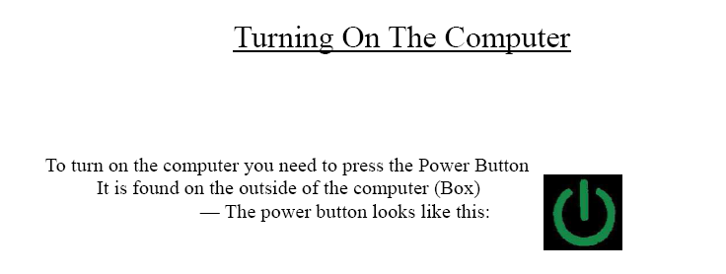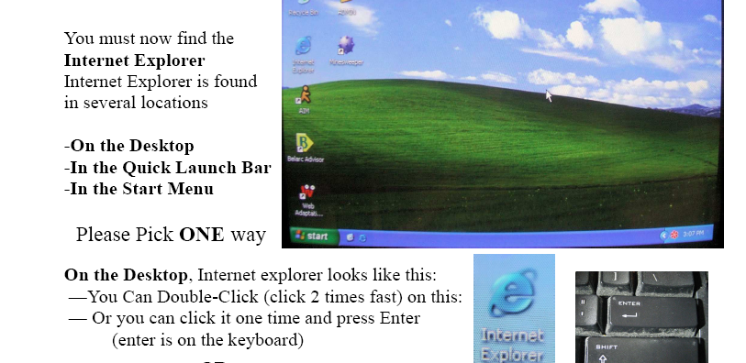

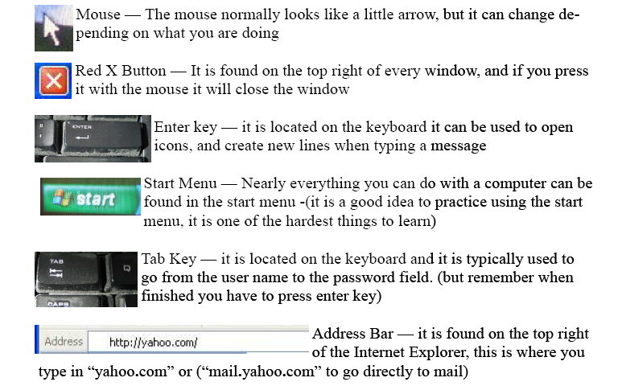


Note: The mouse actually moves/ controls the arrow or pointer around the screen.



Mapping the Livable Community Connections
Mapping Westchester County is an online user-friendly help system created to assist the user with the use and navigation of these GIS Web pages. This help system is designed to help the novice user search, view, analyze, and print geographic information within the County of Westchester, New York.

Access to the Mapping the Livable Community Connections

Senior Programs and Services Website
www.westchestergov.com/seniors
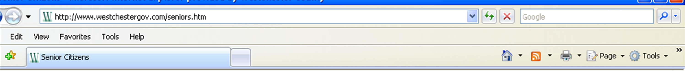

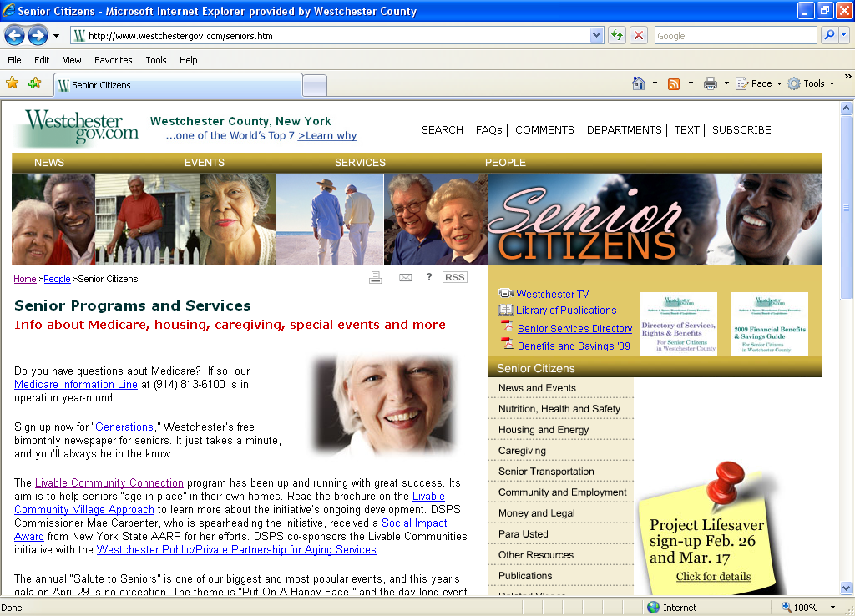

Westchester County Geographic Information Systems (GIS) Website

giswww.westchestergov.com
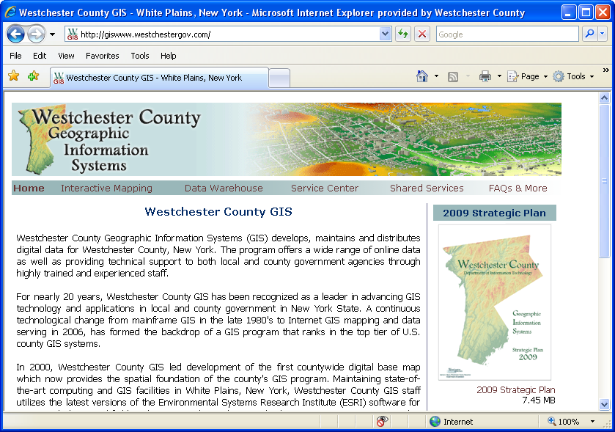

Using the Mapping the Livable Community Connections

Over 14 types of GIS data layers are being inventoried and mapped for each municipality as part of the Livable Communities Initiative. All databases will be integrated with the County’s web mapping program. These layers or categories include learning institutions, hospitals, community centers, houses of worship, transportation, businesses, restaurants, financial institutions, libraries, assisted living facilities, animal hospitals and veterinarians, and health clubs. Asset maps are useful in not only identifying where resources exist, but also where they are needed. The initiative is to help Seniors stay in their homes, with independence, and take advantage of the resources there for them.

The following is a basic, user friendly guide to orient people generally unfamiliar with Computer use to the different screens, procedures and options so that they may begin to access this information.

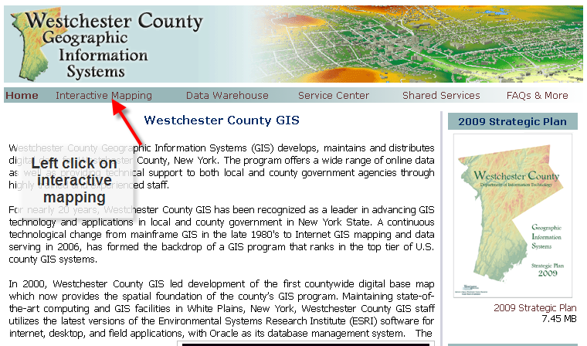
Click on Interactive Mapping

Click on Mapping Westchester

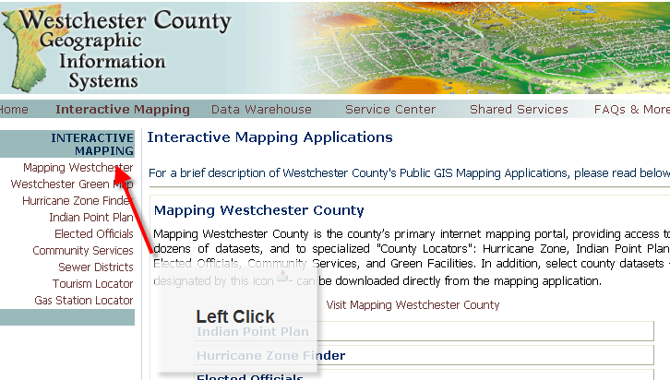

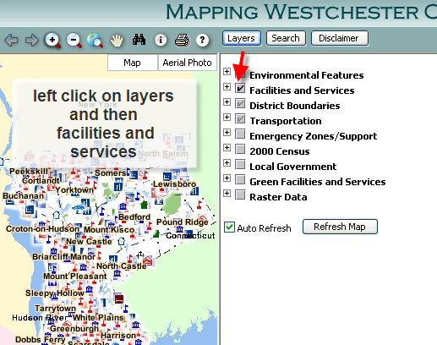

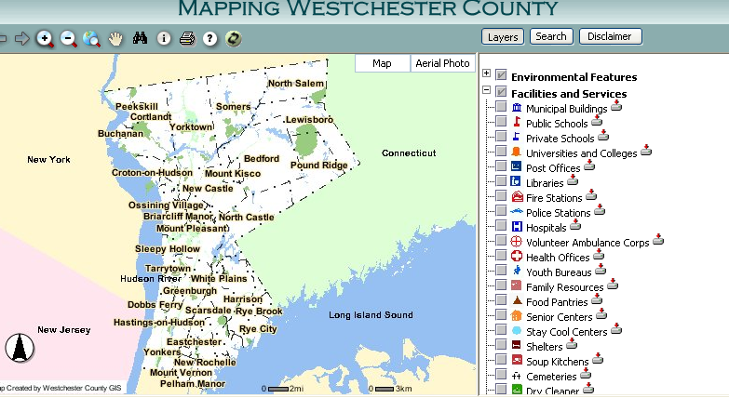

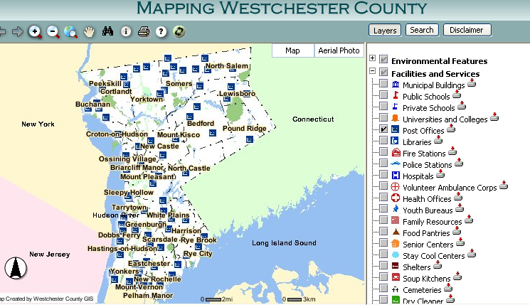

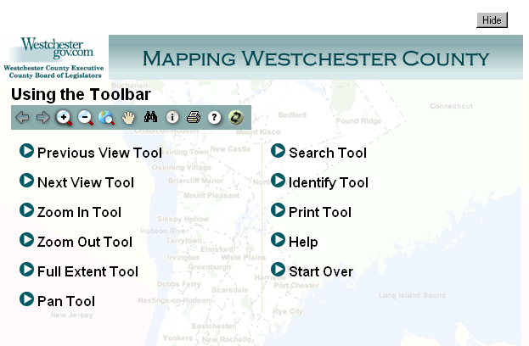

 Learn a new language that you don’t need to hear

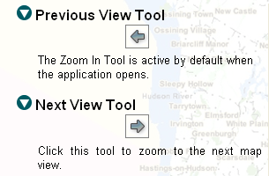
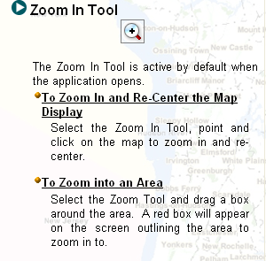

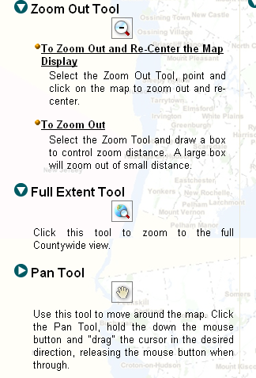

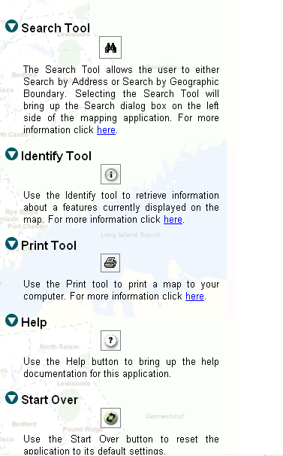

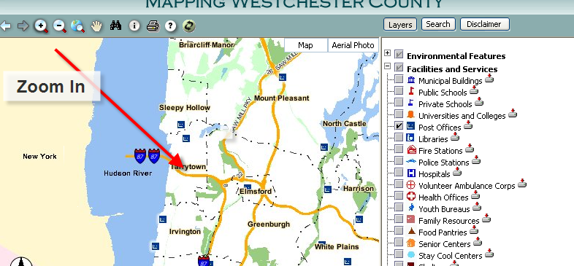

Find out where to take your pet for a trim


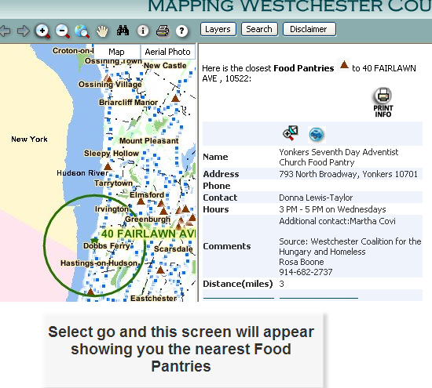

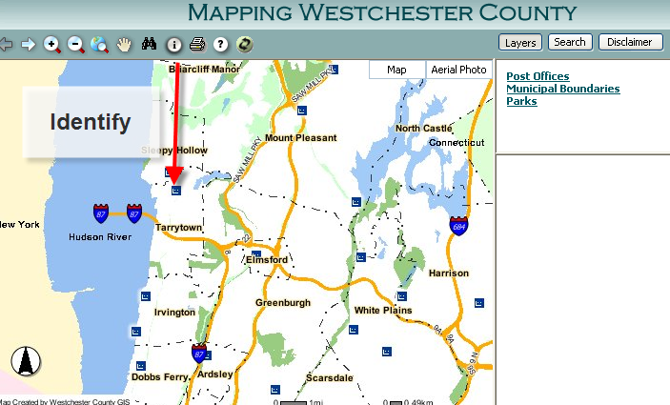

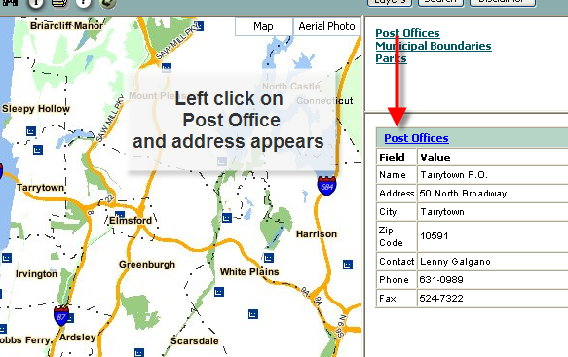

Or, if you have an address and want more information about it or what is in that area:

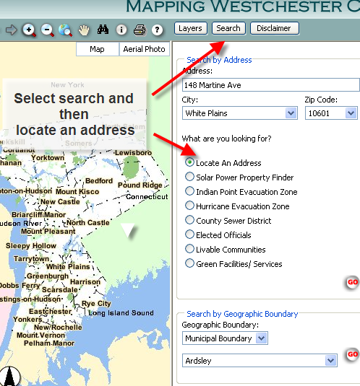

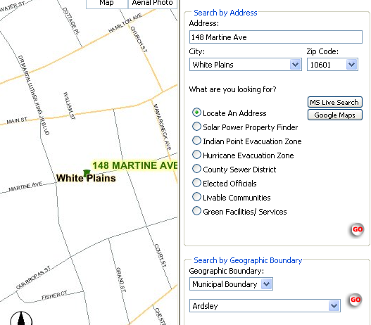

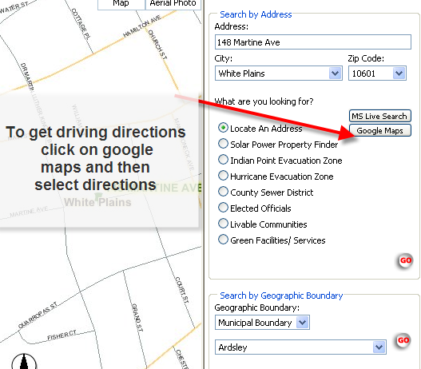

If you no longer drive we can help you get to where you need to go.
By selecting Google Maps (see arrow) you will have the option of getting driving directions, public transit information or walking directions.


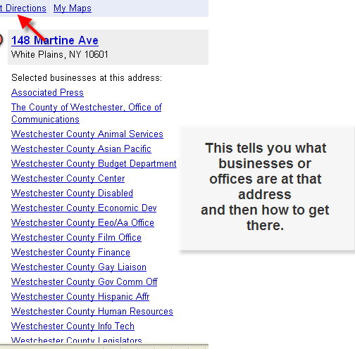

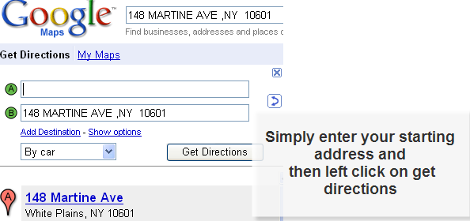
If you need to take the train, place your arrow on the box that says by car and select mass transit to find your transportation options.
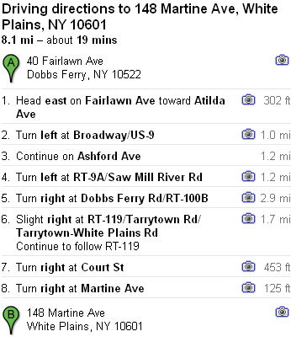

What if you wanted to know what food pantries were closest to you?
How would you do it?

Before


After


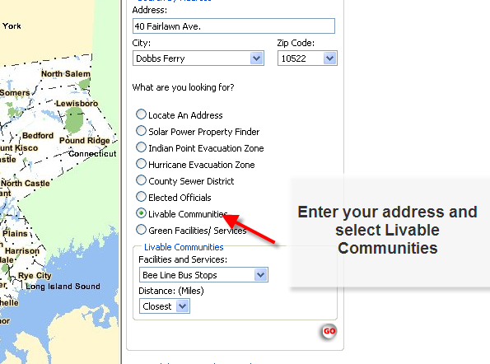

The benefits of the livable communities at your finger tips

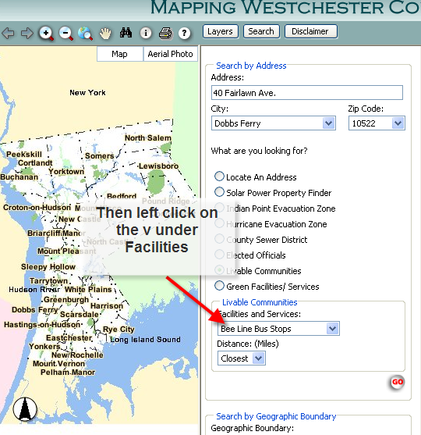

Instead of Bee line Bus select Food Pantries

Try using these tools to search for facilities or services that may be of interest to you or that you are in need of.

TIPS:

- By selecting Bee Line Bus Stops under Facilities and Services, you can find the nearest bus stops to your specified address.

Available search categories, listed under Facilities and Services:
- Adult Homes
- Bee Line Bus Stops
- Cemeteries
- County Regulated Beaches
- Dry Cleaners
- Family Resources
- Fitness Centers
- Food Pantries
- Gas Stations
- Health Offices
- Hospitals
- Libraries
- Municipal Buildings
- National Register Sites
- NYS DMV Offices
- NYS Employment Offices
- Nursing Homes
- Parks
- Post Offices
- Restaurants
- Public Schools
- Publications
- Senior Centers
- Shelters
- Soup Kitchens
- Stay Cool Centers
- Theaters
- Train Stations
- Veterinarians
- Universities and Colleges
- Youth Services
- The address mapping is based on a consistent address format. For instance, Rt. 9, Broadway, and 9 may mean the same thing to you, but it may take a few tries to determine which address format the system uses. Ex: The Post Office in Tarrytown is on Rt. 9, but the mapped address is North Broadway. Remember that you can search by category if you don’t know or can’t find the address.

- The arrow or pointer can turn in to an hourglass if the computer is thinking. It reverts back to an arrow when the selected screen pops up. Depending on the age of the computer it may be so fast that you don’t notice it or it can move slowly. Be patient!

- If you accidentally hit the “Num Lock” key which is to the right of the keyboard above the number keys, you will not be able to enter any numbers. If you have problems getting numbers to appear in the address or zip code boxes tap that key once and see if it corrects the problem.

- If you are getting all capital letters in the boxes, the system should still read the address. However, if you tap the “Caps Lock” key (to the left of the keyboard by the letter A) just once, your letters should come out as lower case.

- To clear your screen or to perform another search inquiry you can either select change search options or select the start over key (See your tool bar reference) to reset the system to default mode.

- Often, the boxes where you are required to enter information have options to select from. For instance, if you entered a street address and then put the arrow on the city box and left click once, the towns and cities of Westchester County appear. You can select the town rather than having to type it in by putting your arrow on the correct town and left clicking. The zip code will automatically be selected for you once you have selected the town or city.

- Try entering addresses that you are already familiar with in terms of their location, and how to get there. That way you can check the system and have a comfort level that the information is correct.

- www.seniorsguidetocomputers.com
A great basic tutorial to expose new users to vocabulary, set up, e-mail, the
internet etc.

The LCC project is part of the larger “Livable Communities Initiative: A Vision for All Ages - Bringing People and Places Together.” The overall initiative is supported by the County’s Department of Senior Programs and Services (DSPS) and the Westchester Public/Private Partnership for Aging Services, Inc.

